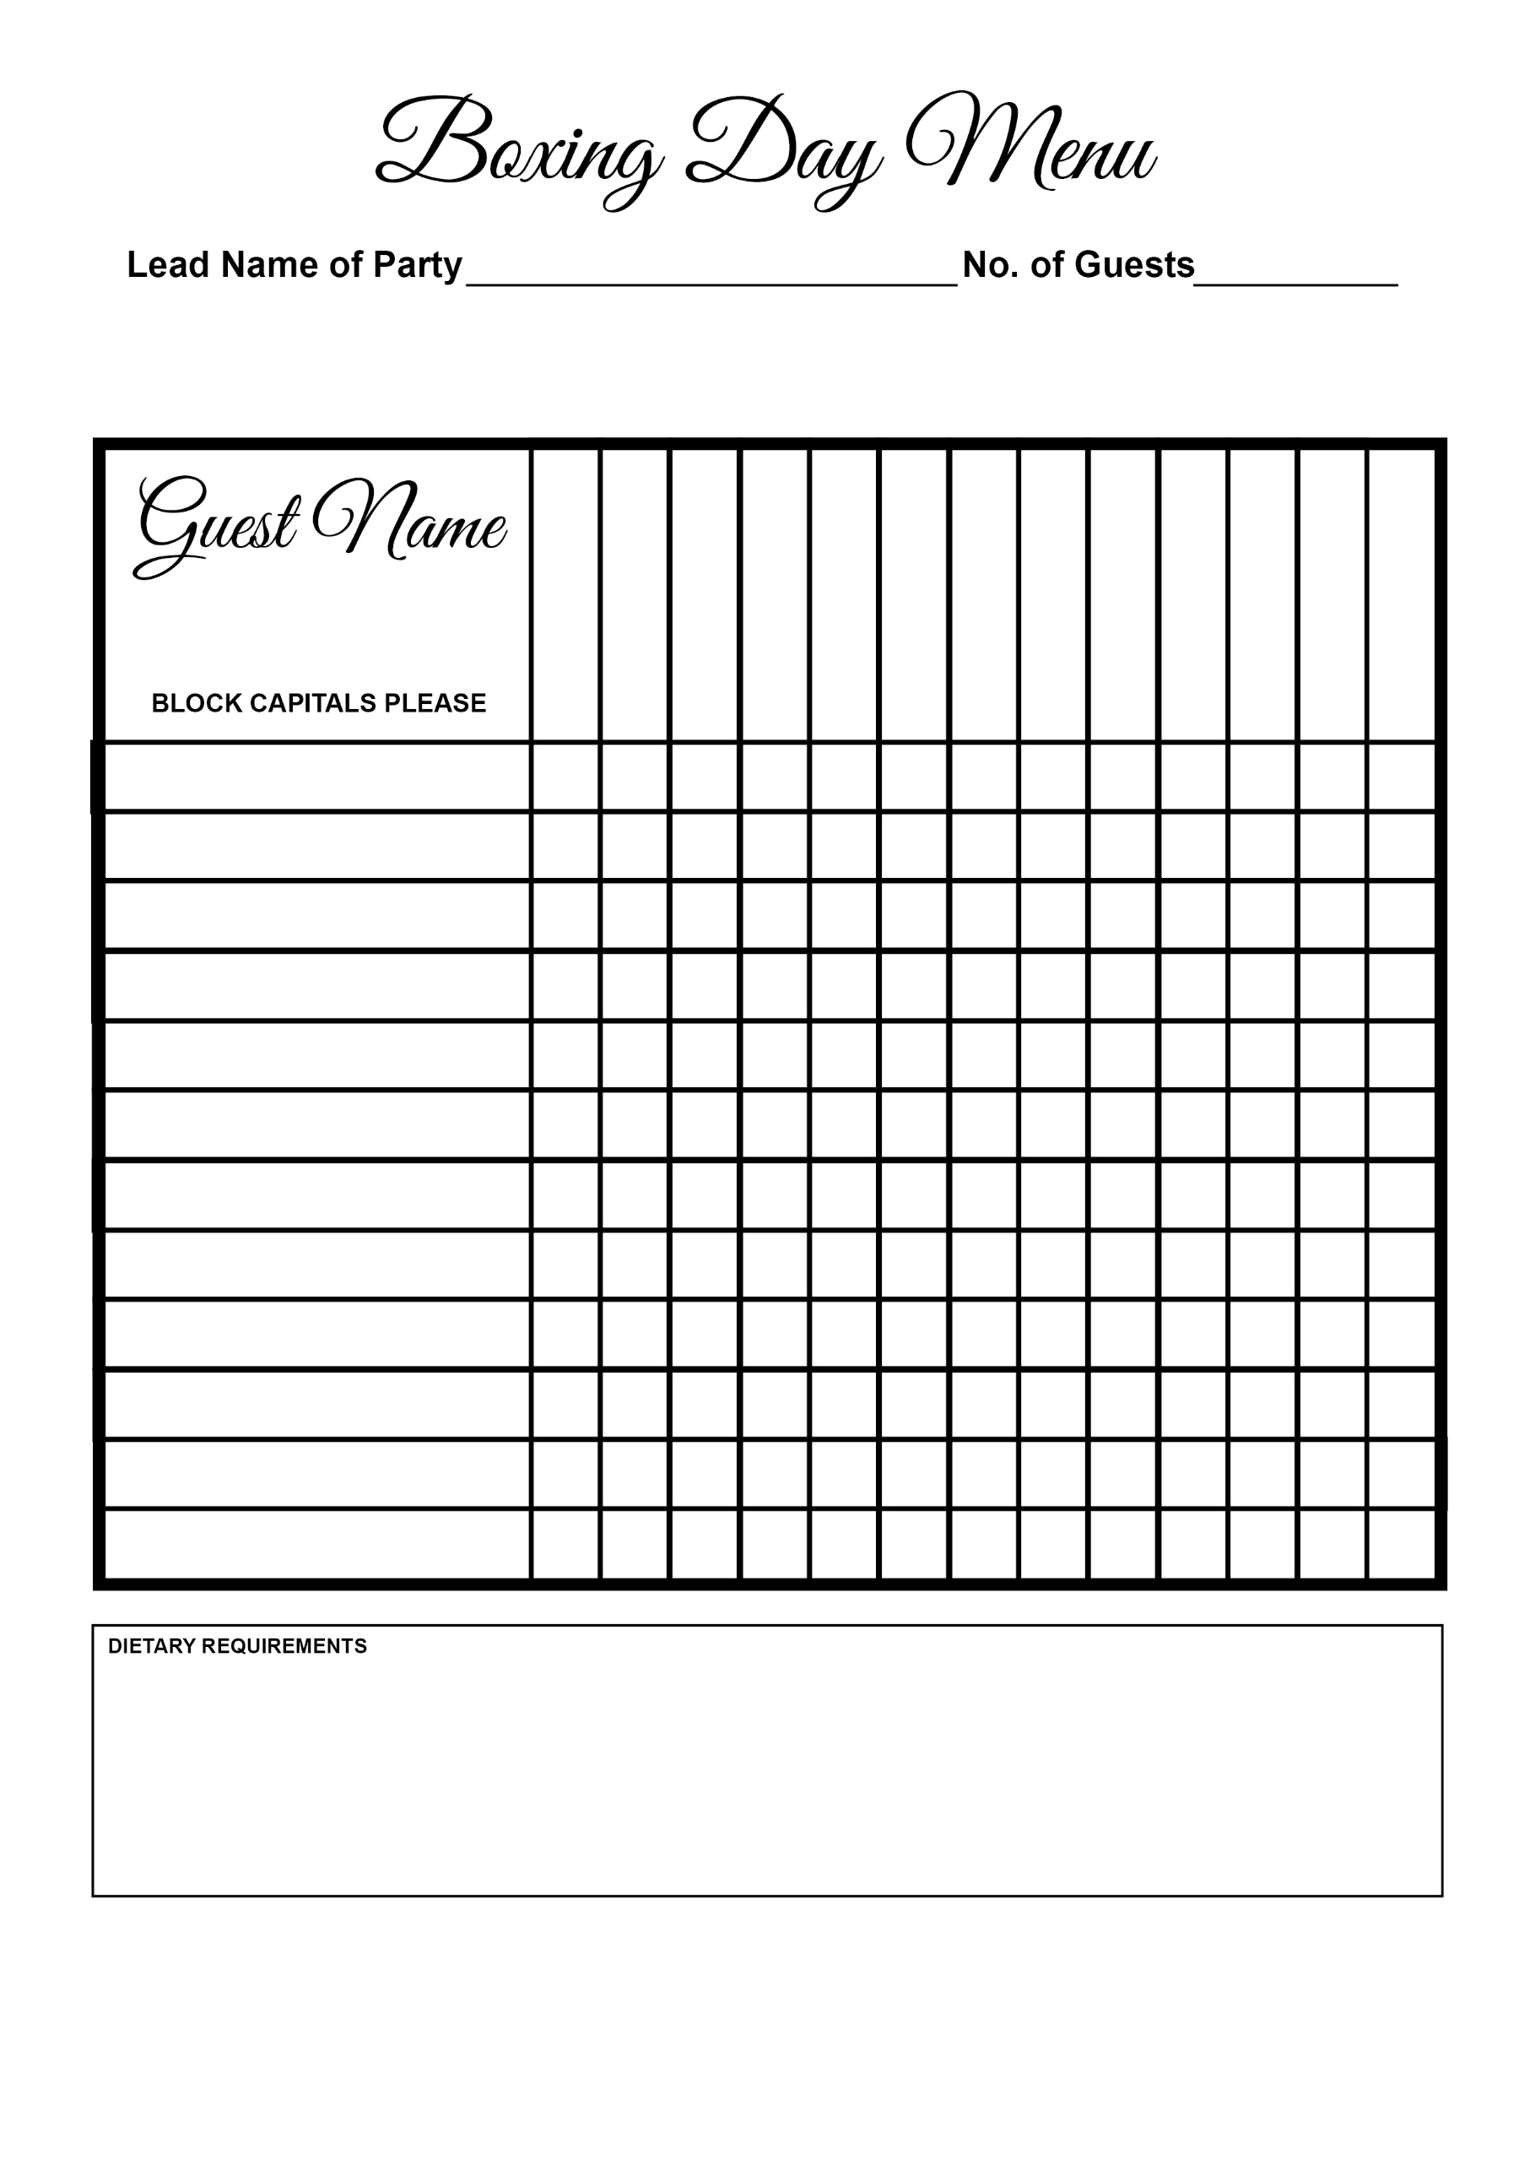



Bread & Butter Pudding

Lemon Tart

Duck

Cranberry Posset

Cheese

Quiche

Sea Bream

Chicken

Beef

Pate

Bubble’n’ Squeak

Soup